Current Activities & Acquisitions

Donations from IBM Norway
The shipment of artefacts from IBM Norway finally arrived during October. We were able to get the lorry reasonably close to the House, and the on-site contractor unloaded everything with a fork-lift into the area in front of the stable block. Unfortunately the load had not been properly tied down, so the heavier machines had moved and caused some damage. It also turned out that a number of artefacts had for some reason not been loaded, so they are still sitting in Oslo until we can find funding to ship.
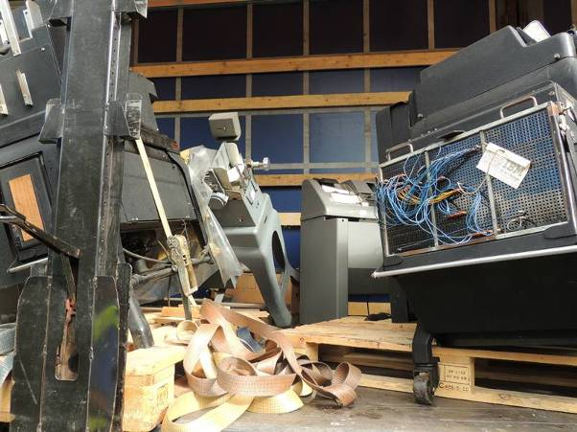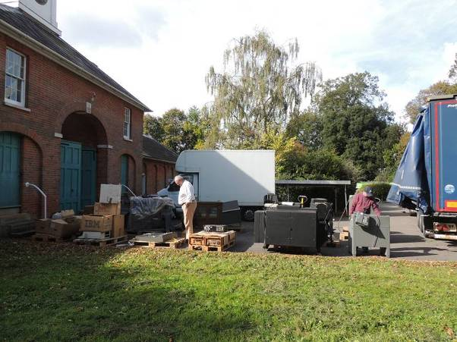
How not to ship heavy stuff Everything unloaded
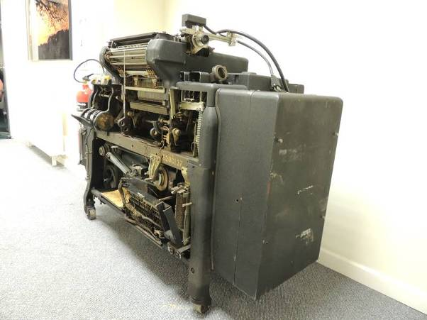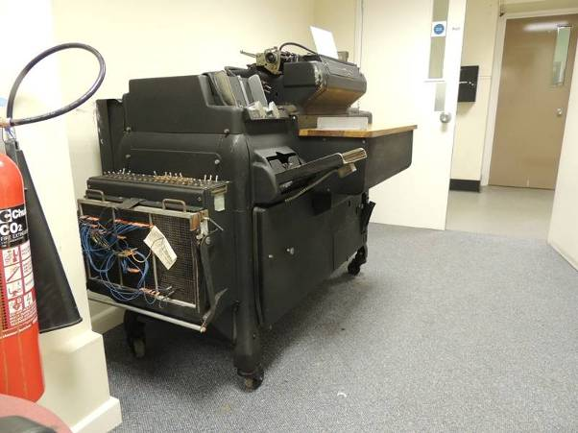
The 416 Tabulator stripped to door width And back together again

Once everything had been unloaded, we three curators were left to move everything into the museum ourselves. By late afternoon we were somewhat knackered, and managed to seek some help to move the remaining machines into the stable block archway until after the weekend. On the Monday we received some help to get the remaining hardware inside. The 416 tabulator gave us an interesting problem. Not only had it lost a wheel, but it was also too wide to get through the door. Anything sticking out the front was removed, and it was wheeled in with millimetres to spare. Rolling a three-wheeled dead weight of several hundred kilos did provide some interesting moments!

Most of the bigger items were put straight out on display, with some dynamic planning centred on what would fit through which doors. Wooden blocks replaced missing legs and wheels for now. The 029 card punch was somewhat legless, so had to be repaired before putting out on display. The remaining items were stored in the back office, and many have now also gone out on display. In particular the ‘Origins of IBM’ story is now in two rooms, one with punch card equipment (the ‘T’ of CTR) and the other with clocks and time recorders (‘R’) and the computing scales (‘C’). Our oldest artefact is now an original Hollerith pantograph card punch, which is dated 1889.
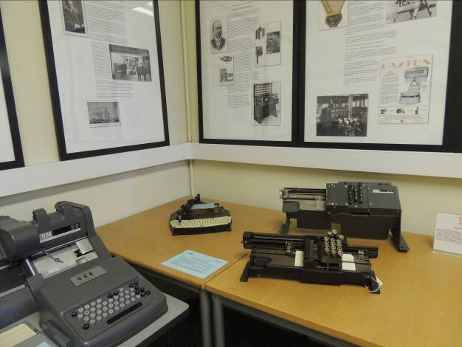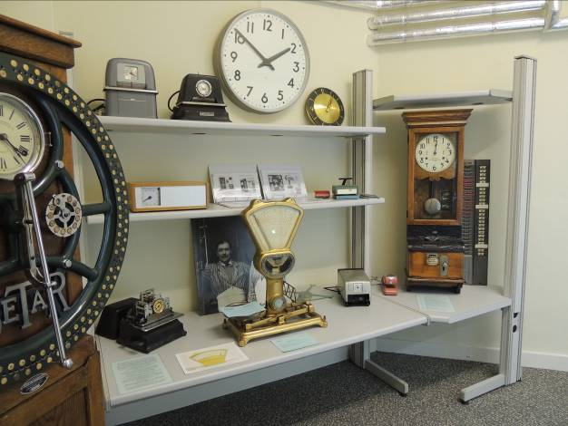
‘__T__’ ‘C____R’

There’s a slide show with a fuller set of photos on the web site at:
http://hursley.slx-online.biz/pictures.asp?pictures=pics-movies/galleries/oslo/oslo.html .

Other Museum Reorganisations
Meanwhile we have also embarked on some major reorganisation of the Personal Computing section. We recently acquired new, narrower shelving for the display tables that allow for three levels instead of two. The PC story now follows a timeline, so portables and ThinkPads are interspersed with PCs and PS/2s. The new display cabinet with the ‘exploded’ 701 Butterfly will be moved into the same room where more changes are planned – although we don’t yet know what the plan is!
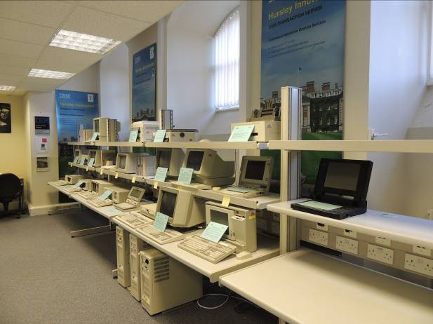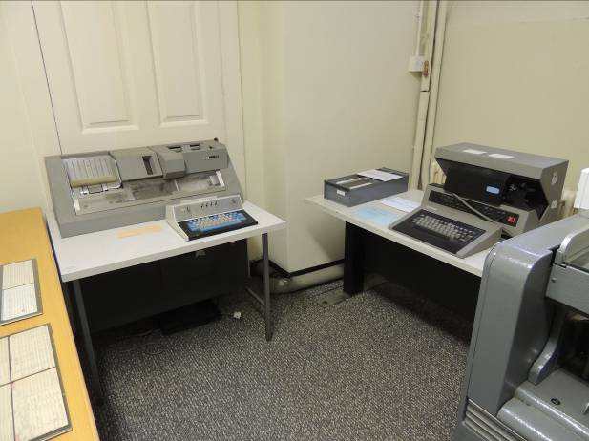
PC – PS/2 Display – work in progress 029 and 5496 from Oslo

